Hyderabad Karnataka Education Society’s
PoojyaDodappaAppa Engineering College,
Kalaburagi
(An Autonomous Institution)
Aiwan-E-Shahi Area, Kalaburagi, Karnataka 585102

Department of Computer Science& Engineering



DATA STRUCTURE WITH C

LAB MANUAL

PREPARED BY
Dr.Pooja Aspalli
Dr.Shilpa Mangshetty

VISION OF THE DEPARTMENT

To become a premier department in computer education, research and to prepare highly competent IT professionals to serve industry and society at local and global levels.

MISSION OF THE DEPARTMENT

- To impart high quality professional education to become a leader in Computer Science and Engineering.
- To achieve excellence in research for contributing to the development of the society.
- To inculcate professional and ethical behaviour to serve the industry.

PROGRAM EDUCATIONAL OBJECTIVES (PEOS)

PEO1: | To prepare graduates with core competencies in mathematical and engineering fundamentals to solve and analyze Computer Science and Engineering problems.
PEO2: | To adapt to evolving technologies and tools for serving the society.
PEO3: | To perform as team leader, effective communicator and socially responsible computer professional in multidisciplinary fields following ethical values.
PEO4: | To encourage students to pursue higher studies, engage in research and to become entrepreneurs.

Table of Contents
Sl.No. | Content
1 | Design, Develop and Implement a menu driven program in C for the following Array operations  - Creating Array of N Integer elements.  - Display of Array elements with suitable headings.  - Inserting an element (ELEM) at a given valid position (POS).  - Deleting an element at a given valid position (POS).  - Exit.  Support the program with functions for each of the above operations
2 | Design, Develop and Implement a program in C for the following operations on Strings  - Read a Main String (STR), a Pattern String (PAT) and a Replace String (REP).  - Perform Pattern Matching Operation: Find and Replace all occurrences of PATin STR with  REP if PAT exists in STR. Repost suitable messages in case PAT does not exist in STR. Support the program with functions for each of the above operations. Don’t use built- in functions.
3 | Design, Develop and Implement a menu driven program in C for the following operations on  STACK of integers (Array implementation of stack with maximum size MAX)  - Push an element on to stack  - Pop an element from stack.  - Display the status of stack.  - Demonstrate Overflow and Underflow situations on stack.  - Exit.  Support the program with appropriate functions for each of the above operations.
4 | Design, Develop and Implement a Program in C for converting an Infix Expression to Postfix Expression. Program should support for both parenthesized and free parenthesized expressions with the operators: +, -, *, /, %(Remainder), ^ (Power) and alphanumeric operands.
5 | Design, Develop and Implement a Program in C for the following Stack Applications  - Evaluation of Postfix expression
6 | Design, Develop and Implement a menu driven Program in C for the following operations on QUEUE of Characters (Array Implementation of Queue with maximum size MAX)  - Insert an Element on to QUEUE  - Delete an Element from QUEUE  - Demonstrate Overflow and Underflow situations on QUEUE  - Display the status of QUEUE  - Exit  Support the program with appropriate functions for each of the above operations
7 | Design, Develop and Implement a menu driven Program in C for the following operations on Singly Linked List (SLL) of integer values  - Create a SLL of N integers by using front insertion.  - Display the status of SLL and count the number of nodes in it  - Perform Insertion and Deletion at End of SLL  - Perform Insertion and Deletion at Front of SLL
8 | Design, Develop and Implement Program in C to Reverse a Singly Linked List (SLL) of a given integers.
9 | Design, Develop and Implement a menu driven Program in C for the following operations on Priority queue  - Create a Priority queue by using Insert function  - Insertion data and priority values as input  - Perform Deletion operation  - Display the elements of Priority queue
10 | Design, Develop and Implement a menu driven Program in C for the following operations on Binary Search Tree (BST) of Integers  a. Create a BST of N Integers: 6, 9, 5, 2, 8, 15, 24, 14, 7, 8, 5, 2  - Traverse the BST in Inorder,  - Traverse the BST in Preorder  - Traverse the BST in Post Order
11 | Given a File of N employee records with a set K of Keys(4- digit) which uniquely determine the records in file F. Assume that file F is maintained in memory by a Hash Table(HT) of m memory locations with L as the set of memory addresses (2- digit) of locations in HT. Let the keys in K and Addresses in L are Integers. Design and develop a Program in C that uses Hash function H: K ®L as H(K)=K mod m (remainder method), and implement hashing technique to map a given key K to the address space L. Resolve the collision (if any) using linear probing

Data Structures with C Lab

INTRODUCTION TO DATA STRUCTURES

Data Structure is defined as the way in which data is organized in the memory location.

There are 2 types of data structures:
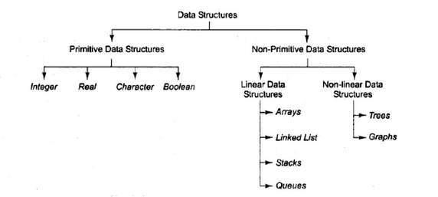

Linear Data Structure:

In linear data structure all the data are stored linearly or contiguously in the memory. All the data are saved in continuously memory locations and hence all data elements are saved in one boundary. A linear data structure is one in which we can reach directly only one element from another while travelling sequentially. The main advantage, we find the first element, and then it’s easy to find the next data elements. The disadvantage, the size of the array must be known before allocating the memory.

The different types of linear data structures are:
- Array
- Stack
- Queue
- Linked List

Non-Linear Data Structure:

Every data item is attached to several other data items in a way that is specific for reflecting relationships. The data items are not arranged in a sequential structure.

The various types of non linear data structures are:
- Trees
- Graphs

Data Structures with C Lab

EXPERIMENT - 01

Design, Develop and Implement a menu driven program in C for the following Array operations
- Creating Array of N Integer elements.
- Display of Array elements with suitable headings.
- Inserting an element (ELEM) at a given valid position (POS).
- Deleting an element at a given valid position (POS).
- Exit.
Support the program with functions for each of the above operations.

ABOUT THE EXPERIMENT:
An Array is a collection of similar / same elements. In this experiment the array can be represented as one / single dimensional elements.

Menu driven program in c - language to perform various array operations are implemented with the help of user defined functions as followings;

- create()
- display()
- insert()
- del ()
- exit()

ALGORITHM:
Step 1: Start.
Step 2: Read N value.

Step 3: Read Array of N integer elements
Step 4: Print array of N integer elements.
Step 5: Insert an element at given valid position in an array.
Step 6: Delete an element at given valid position from an array.
Step 7: Stop.

PROGRAM CODE:
#include<stdio.h>
#include<conio.h>
/* Global variables declaration */
int a[4], n, elem, i, pos;

/*Function Prototype and Definitions*/

void create()
{

//creating an array

printf("\nEnter the size of the array elements: ");
scanf("%d", &n);
printf("\nEnter the elements for the array:\n");
for(i=0; i<n; i++)

Data Structures with C Lab

scanf("%d", &a[i]);
}//end of create()

void display()

{

//displaying an array elements

int i;
printf("\nThe array elements are:\n");
for(i=0; i<n; i++)
{
printf("%d\t", a[i]);
}
}//end of display()

void insert() //inserting an element in to an array
{
printf("\nEnter the position for the new element: ");
scanf("%d", &pos);
printf("\nEnter the element to be inserted: ");
scanf("%d", &elem);
for(i=n-1; i>=pos; i--)
{
a[i+1] = a[i];
}
a[pos] = elem;
n = n+1;
}//end of insert()

void del()

{

//deleting an array element

printf("\nEnter the position of the element to be deleted: ");
scanf("%d", &pos);
elem = a[pos];
for(i=pos; i<n-1; i++)
{
a[i] = a[i+1];

}
n = n-1;

printf("\nThe deleted element is = %d", elem); }//end of delete()

void main()
{

Data Structures with C Lab

int ch;
clrscr();
do{
 |  | printf("\n\n |  |  | --------Menu----------- | \n");
 |  | printf("1.Create\n 2.Display\n 3.Insert\n 4.Delete\n 5.Exit\n");
 |  | printf("------------------------------- |  |  |  | ");
 |  | printf("\nEnter your choice: ");
 |  | scanf("%d", &ch);
 |  | switch(ch)
 |  | {
 |  |  |  | case 1: create();
 |  |  |  |  | break;
 |  |  |  | case 2: display();
 |  |  |  |  | break;
 |  |  |  | case 3: insert();
 |  |  |  |  | break;
 |  |  |  | case 4: del();
 |  |  |  |  | break;
 |  |  |  | case 5: exit(0);
 |  |  |  |  | break;
 |  |  |  | default: printf("\nInvalid choice:\n");
 |  |  |  |  | break;
 |  | }
 | }while(ch!=5);
 | getch();
}// end of main
SAMPLE OUTPUT:
--------Menu-----------
1.Create
2.Display
3.Insert
4.Delete
5.Exit
Enter your choice: |  |  |  | 1
Enter the size of the array elements: 5
Enter the elements for the array:
10 | 20 | 30 | 40 |  | 50
--------Menu-----------
1.Create
2.Display
3.Insert
4.Delete
5.Exit

Data Structures with C Lab
Enter your choice: |  |  | 2
The array elements are:
10 | 20 | 30 | 40 | 50
--------Menu-----------
1.Create
2.Display
3.Insert
4.Delete
5.Exit
Enter your choice: |  |  | 3
Enter the position for the new element: |  |  |  |  |  | 2
Enter the element to be inserted: |  |  |  |  | 90
--------Menu-----------
1.Create
2.Display
3.Insert
4.Delete
5.Exit
Enter your choice: |  |  | 2
The array elements are:
10 | 20 | 90 | 30 | 40 | 50
--------Menu-----------
1.Create
2.Display
3.Insert
4.Delete
5.Exit
Enter your choice: |  |  | 4
Enter the position of the element to be deleted: |  |  |  |  |  | 5
The deleted element is = |  |  |  | 50
--------Menu-----------
1.Create
2.Display
3.Insert
4.Delete
5.Exit
Enter your choice: |  |  | 2

The array elements are:
10 20 90 30 40

--------Menu-----------
1.Create

Data Structures with C Lab

2.Display
3.Insert
4.Delete
5.Exit
Enter your choice: 5

Data Structures with C Lab

EXPERIMENT - 02

Design, Develop and Implement a program in C for the following operations on Strings
- Read a Main String (STR), a Pattern String (PAT) and a Replace String (REP).

- Perform Pattern Matching Operation: Find and Replace all occurrences of PAT in STR with REP if PAT exists in STR. Repost suitable messages in case PAT does not exist in STR.

Support the program with functions for each of the above operations. Don’t use built-in functions.

ABOUT THE EXPERIMENT:
Strings are actually one-dimensional array of characters terminated by a null character '\0'.

Thus a null-terminated string contains the characters that comprise the string followed by a null.

The following declaration and initialization create a string consisting of the word "Hello". To hold the null character at the end of the array, the size of the character array containing the string is one more than the number of characters in the word "Hello."

char greeting[6] = {'H', 'e', 'l', 'l', 'o', '\0'};

If you follow the rule of array initialization then you can write the above statement as follows:

char greeting[] = "Hello";

C language supports a wide range of built-in functions that manipulate null-terminated strings as follows:

strcpy(s1, s2); Copies string s2 into string s1.
strcat(s1, s2); Concatenates string s2 onto the end of string s1.
strlen(s1); Returns the length of string s1.
strcmp(s1, s2);Returns 0 if s1 and s2 are the same; less than 0 if s1<s2; greater than 0 if s1>s2.
strchr(s1, ch); Returns a pointer to the first occurrence of character ch in string s1.
strstr(s1, s2); Returns a pointer to the first occurrence of string s2 in string s1.

ALGORITHM:
Step 1: Start.
Step 2: Read main string STR, pattern string PAT and replace string REP.

Step 3: Search / find the pattern string PAT in the main string STR.
Step 4: if PAT is found then replace all occurrences of PAT in main string STR with REP string.
Step 5: if PAT is not found give a suitable error message.

Step 6: Stop.

PROGRAM CODE:

#include<stdio.h>
#include<conio.h>

//Declarations

Data Structures with C Lab

char str[100], pat[50], rep[50], ans[100];
int i, j, c, m, k, flag=0;

void stringmatch()
{
i = m = c = j = 0;
while(str[c] ! = '\0')
{
if(str[m] = = pat[i]) // ...... matching
{

i++; m++;

if(pat[i] = = '\0')

{

//.....found occurrences.

flag = 1;
//.... copy replace string in ans string.
for(k = 0; rep[k] != '\0'; k++, j++)
ans[j] = rep[k];
i = 0;
c = m;
}
}// if ends.

else
{
//... mismatch

ans[j] = str[c];
j++;
c++;
m = c;
i = 0;
}//else ends

} //end of while ans[j] = '\0';
} //end stringmatch()

void main()
{
clrscr();
printf("\nEnter a main string \n");

gets(str);
printf("\nEnter a pattern string \n");
flushall();
gets(pat);
printf("\nEnter a replace string \n");
flushall();
gets(rep);
stringmatch();
if(flag = = 1)

Data Structures with C Lab

printf("\nThe resultant string is\n %s" , ans);
else
printf("\nPattern string NOT found\n");

getch();
}// end of main

SAMPLE OUTPUT:

RUN 1:
Enter a main string

Test
Enter a pattern string
Te

Enter a replace string
Re

The resultant string is
Rest

RUN 2:
Enter a main string

This is Data Structure lab
Enter a pattern string
Data Structure
Enter a replace string
Data structure with C

The resultant string is
This is Data structure with C lab

RUN 3:
Enter a main string

This is Data Structure lab
Enter a pattern string
Date

Enter a replace string
DATA

Pattern string NOT found

Data Structures with C Lab

EXPERIMENT - 03

Design, Develop and Implement a menu driven program in C for the following operations on STACK of integers (Array implementation of stack with maximum size MAX)

  - Push an element on to stack b. Pop an element from stack.
- Demonstrate how stack can be used to check palindrome.
- Demonstrate Overflow and Underflow situations on stack.
- Display the status of stack.
- Exit.
Support the program with appropriate functions for each of the above operations.

ABOUT THE EXPERIMENT:

A stack is an abstract data type (ADT), commonly used in most programming languages. It is named stack as it behaves like a real-world stack.


A real-world stack allows operations at one end only. For example, we can place or remove a card or plate from top of the stack only. Likewise, Stack ADT allows all data operations at one end only. At any given time, we can only access the top element of a stack.

This feature makes it LIFO data structure. LIFO stands for Last-in-first-out. Here, the element which is placed (inserted or added) last is accessed first. In stack terminology, insertion operation is called PUSH operation and removal operation is called POP operation.

Below given diagram tries to depict a stack and its operations −
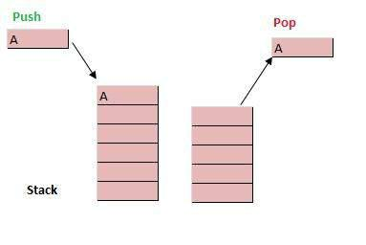

Data Structures with C Lab

A stack can be implemented by means of Array, Structure, Pointer and Linked-List. Stack can either be a fixed size one or it may have a sense of dynamic resizing. Here, we are going to implement stack using arrays which makes it a fixed size stack implementation.

Basic Operations:
- push() - pushing (storing) an element on the stack.
- pop() - removing (accessing) an element from the stack.

To use a stack efficiently we need to check status of stack as well. For the same purpose, the following functionality is added to stacks;
- peek() − get the top data element of the stack, without removing it.
- isFull() − check if stack is full.
- isEmpty() − check if stack is empty.

ALGORITHM:
Step 1: Start.
Step 2: Initialize stack size MAX and top of stack -1.
Step 3: Push integer element on to stack and display the contents of the stack.
if stack is full give a message as ‘Stack is Overflow’.
Step 3: Pop element from stack along with display the stack contents.
if stack is empty give a message as ‘Stack is Underflow’.
Step 4: Check whether the stack contents are Palindrome or not.
Step 5: Stop.

PROGRAM CODE:

#include<stdio.h>
#include<conio.h>

#define MAX 4

int stack[MAX], item;
int ch, top = -1, count = 0, status = 0;

/*PUSH FUNCTION*/
void push(int stack[], int item)
{
if (top == (MAX-1))

printf("\n\nStack is Overflow");
else
{
stack[++top] = item;
status++;
}

}

Data Structures with C Lab

/*POP FUNCTION*/
int pop(int stack[])
{
int ret;
if(top == -1)
printf("\n\nStack is Underflow");
else
{
ret = stack[top--];
status--;
printf("\nPopped element is %d", ret);
}

return ret;

}

/* FUNCTION TO CHECK STACK IS PALINDROME OR NOT */
void palindrome(int stack[])
{
int i, temp;
temp = status;
for(i=0; i<temp; i++)
{
if(stack[i] == pop(stack))
count++;
}
if(temp==count)
printf("\nStack contents are Palindrome");
else
printf("\nStack contents are not palindrome");
}

/*FUNCTION TO DISPLAY STACK*/
void display(int stack[])
{
int i;
printf("\nThe stack contents are:");
if(top == -1)
printf("\nStack is Empty");

else{
for(i=top; i>=0; i--)
printf("\n ------\n| %d |", stack[i]);
printf("\n");
}
}

/*MAIN PROGRAM*/
void main()

Data Structures with C Lab

{
clrscr();
do{
printf("\n\n----MAIN MENU----\n");
printf("\n1. PUSH (Insert) in the Stack");
printf("\n2. POP (Delete) from the Stack");
printf("\n3. PALINDROME check using Stack");
printf("\n4. Exit (End the Execution)");
printf("\nEnter Your Choice: ");
scanf("%d", &ch);

switch(ch){
case 1: printf("\nEnter a element to be pushed: ");
scanf("%d", &item);

push(stack, item);
display(stack);
break;
case 2: item=pop(stack);
display(stack);
break;
case 3:
palindrome(stack);
break;
case 4:
exit(0); break;
default:
printf("\nEND OF EXECUTION");
}//end switch
}while (ch != 4);
getch();
}

SAMPLE OUTPUT:
----MAIN MENU----
- PUSH (Insert) in the Stack
- POP (Delete) from the Stack
- PALINDROME check using Stack

- Exit (End the Execution)
Enter Your Choice: | 1
Enter an element to be pushed: |  | 1

The stack contents are:
-----
| 1 |

----MAIN MENU----
- PUSH (Insert) in the Stack

- POP (Delete) from the Stack

Data Structures with C Lab

- PALINDROME check using Stack
- Exit (End the Execution)

Enter Your Choice: 1
Enter an element to be pushed:
The stack contents are:

------
| 2 |
------|

1 |

2

(-------- AFTER THE 4 TIMES PUSH OPERATION -------)

----MAIN MENU----

- PUSH (Insert) in the Stack
- POP (Delete) from the Stack
- PALINDROME check using Stack

- Exit (End the Execution)
Enter Your Choice: | 1
Enter an element to be pushed: |  | 9

Stack is Overflow
The stack contents are:
------

| 1 |
------

| 2 |
------|
2 |

------|
1 |

----MAIN MENU----

- PUSH (Insert) in the Stack
- POP (Delete) from the Stack

- PALINDROME check using Stack
- Exit (End the Execution)
Enter Your Choice: | 2
Popped element is | 1

The stack contents are:
------
| 2 |

------|
2 |
------|
1 |

(-------- AFTER THE 4 TIMES POP OPERATION -------)
----MAIN MENU----

- PUSH (Insert) in the Stack
- POP (Delete) from the Stack
- PALINDROME check using Stack

- Exit (End the Execution)
Enter Your Choice: | 2
Stack is Underflow
The stack contents are:
Stack is Empty

Data Structures with C Lab
(-------- | CHECKING FOR PALINDROME OR NOT USING STACK | -------)
----MAIN MENU----
- PUSH (Insert) in the Stack
- POP (Delete) from the Stack
- PALINDROME check using Stack

- Exit (End the Execution)
Enter Your Choice: | 1
Enter an element to be pushed: |  | 1

The stack contents are:
-----

| 1 |

----MAIN MENU----
- PUSH (Insert) in the Stack

- POP (Delete) from the Stack
- PALINDROME check using Stack
- Exit (End the Execution)
Enter Your Choice: | 1
Enter an element to be pushed: |  | 2

The stack contents are:
------
| 2 |

------|
1 |

----MAIN MENU----
- PUSH (Insert) in the Stack
- POP (Delete) from the Stack

- PALINDROME check using Stack
- Exit (End the Execution)

Enter Your Choice: | 1
Enter a element to be pushed: |  | 1

The stack contents are:
------

| 1 |
------|

- |
------|
- |

----MAIN MENU----
- PUSH (Insert) in the Stack

- POP (Delete) from the Stack

- PALINDROME check using Stack

- Exit (End the Execution)

Enter Your Choice: 3

Stack contents are is Palindrome

(-------- CHECKING FOR PALINDROME OR NOT USING STACK-------)
----MAIN MENU----

- PUSH (Insert) in the Stack
- POP (Delete) from the Stack
- PALINDROME check using Stack

- Exit (End the Execution)
Enter Your Choice: | 1

Data Structures with C Lab
Enter an element to be pushed: | 1
The stack contents are:

-----|
1 |

(AFTER 3 TIMES PUSH)
----MAIN MENU----
- PUSH (Insert) in the Stack
- POP (Delete) from the Stack

- PALINDROME check using Stack
- Exit (End the Execution)

Enter Your Choice: | 1
Enter an element to be pushed: |  | 3

The stack contents are:
------
| 3 |

------|
- |
------|

- |

----MAIN MENU----
- PUSH (Insert) in the Stack
- POP (Delete) from the Stack
- PALINDROME check using Stack

- Exit (End the Execution)
Enter Your Choice: | 3

Stack contents are not Palindrome

Data Structures with C Lab

EXPERIMENT - 04

Design, Develop and Implement a Program in C for converting an Infix Expression to Postfix Expression. Program should support for both parenthesized and free parenthesized expressions with the operators: +, -, *, /, %( Remainder), ^ (Power) and alphanumeric operands.

ABOUT THE EXPERIMENT:
Infix: Operators are written in-between their operands. Ex: X + Y
Prefix: Operators are written before their operands. Ex: +X Y
postfix: Operators are written after their operands. Ex: XY+

Examples of Infix, Prefix, and Postfix

Infix Expression | Prefix Expression | Postfix Expression
A + B | + A B | A B +
A+B*C | +A*BC | ABC*+

Infix to prefix conversion Expression = (A+B^C)*D+E^5 Step 1. Reverse the infix expression.

5^E+D*)C^B+A(
Step 2. Make Every '(' as ')' and every ')' as '('

5^E+D*(C^B+A)
Step 3. Convert expression to postfix form.

Step 4. Reverse the expression.

+*+A^BCD^E
Step 5. Result

+*+A^BCD^E5

A+(B*C-(D/E-F)*G)*H

 | Expression |  | Stack |  | Output |  | Comment
5^E+D*(C^B+A) |  |  | Empty |  |  |  | Initial
 |  |  | Empty |  | - |  | Initial
 | ^E+D*(C^B+A) |  | Empty |  | 5 |  | Print
E+D*(C^B+A) |  |  |  |  |  |  | Push
 |  |  | ^ |  | 5 |  | Push
 | +D*(C^B+A) |  | ^ |  | 5E |  | Push
D*(C^B+A) |  |  |  |  | 5E^ |  | Pop And Push
 |  |  | + |  | 5E^ |  | Pop And Push
 | *(C^B+A) |  | + |  | 5E^D |  | Print
(C^B+A) |  |  |  |  | 5E^D |  | Push
 |  |  | +* |  | 5E^D |  | Push


C^B+A)

^B+A)


B+A)

+A)

A)

)

End

End

 | +*( |  | 5E^D |  | Push
 | +*( |  | 5E^DC |  | Print
 | +*(^ |  | 5E^DC |  | Push
 | +*(^ |  | 5E^DCB |  | Print
 | +*(+ |  | 5E^DCB^ |  | Pop And Push
 | +*(+ |  | 5E^DCB^A |  | Print
 | +* |  | 5E^DCB^A+ |  | Pop Until '('
 | Empty |  | 5E^DCB^A+*+ |  | Pop Every element


Data Structures with C Lab

ALGORITHM:
Step 1: Start.
Step 2: Read an infix expression with parenthesis and without parenthesis.

Step 3: convert the infix expression to postfix expression.
Step 4: Stop

PROGRAM CODE:

#include <stdio.h>
#include <string.h>
#include <limits.h>
#include <stdlib.h>

struct Stack {
int top;
int maxSize;
int* array;
};

struct Stack* create(int max)
{
struct Stack* stack = (struct Stack*)malloc(sizeof(struct Stack));
stack -> maxSize = max;
stack -> top = -1;
stack -> array = (int*)malloc(stack -> maxSize * sizeof(int));
return stack;
}

int isFull(struct Stack* stack)
{
if(stack -> top == stack -> maxSize - 1) {
printf("Will not be able to push maxSize reached\n");
}
return stack -> top == stack -> maxSize - 1;
}

int isEmpty(struct Stack* stack)
{
return stack -> top == -1;
}

void push(struct Stack* stack, int item)
{
if (isFull(stack))
return;
stack -> array[++stack -> top] = item;
}

int pop(struct Stack* stack)
{
if (isEmpty(stack))
return INT_MIN;
return stack -> array[stack -> top--];
}

int peek(struct Stack* stack)
{
if (isEmpty(stack))
return INT_MIN;
return stack->array[stack->top];
}
int checkIfOperand(char ch)
{
return (ch >= 'a' && ch <= 'z') || (ch >= 'A' && ch <= 'Z');
}
int precedence(char ch)
{
switch (ch)
{
case '+':
case '-':
return 1;

case '*':
case '/':
return 2;

case '^':
return 3;
}
return -1;
}

int covertInfixToPostfix(char* expression)
{
int i, j;

struct Stack* stack = create(strlen(expression));
if(!stack)
return -1 ;

for (i = 0, j = -1; expression[i]; ++i)
{
if (checkIfOperand(expression[i]))
expression[++j] = expression[i];

else if (expression[i] == '(')
push(stack, expression[i]);

else if (expression[i] == ')')
{
while (!isEmpty(stack) && peek(stack) != '(')
expression[++j] = pop(stack);
if (!isEmpty(stack) && peek(stack) != '(')
return -1;
else
pop(stack);
}
else
{
while (!isEmpty(stack) && precedence(expression[i]) <= preceence(peek(stack)))
expression[++j] = pop(stack);
push(stack, expression[i]); }

}

while (!isEmpty(stack))
expression[++j] = pop(stack);

expression[++j] = '\0';
printf( "%s", expression);
}

int main()
{
char expression[] = "((x+(y*z))-w)";
covertInfixToPostfix(expression);
return 0;
}

Data Structures with C Lab

SAMPLE OUTPUT:
Enter a valid infix expression
A+B
The infix expression is:
A+B

The postfix expression is:
AB+

Data Structures with C Lab

EXPERIMENT - 05

Design, Develop and Implement a Program in C for the following Stack Applications
a. Evaluation of Suffix expression

ABOUT THE EXPERIMENT:

a. Evaluation of Suffix expression with single digit operands and operators: +, -, *, /, %, ^

Postfix/Suffix Expression: Operators are written after their operands. Ex: XY+
In normal algebra we use the infix notation like a+b*c. The corresponding postfix notation is abc*+

Example: Postfix String: 123*+4-

Initially the Stack is empty. Now, the first three characters scanned are 1,2 and 3, which are operands. Thus they will be pushed into the stack in that order.
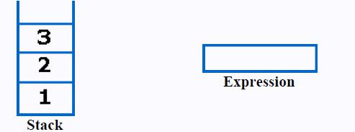

Next character scanned is "*", which is an operator. Thus, we pop the top two elements from the stack and perform the "*" operation with the two operands. The second operand will be the first element that is popped.
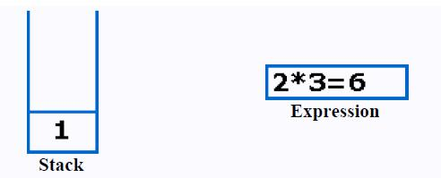

The value of the expression(2*3) that has been evaluated(6) is pushed into the stack.
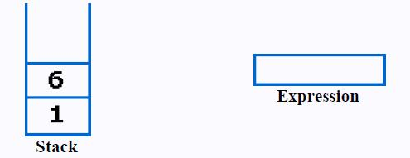

Data Structures with C Lab

Next character scanned is "+", which is an operator. Thus, we pop the top two elements from the stack and perform the "+" operation with the two operands. The second operand will be the first element that is popped.
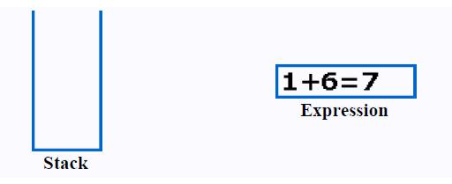

The value of the expression(1+6) that has been evaluated(7) is pushed into the stack.
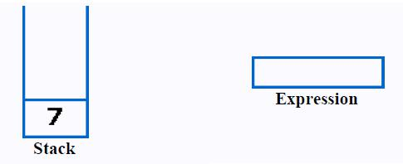

Next character scanned is "4", which is added to the stack.
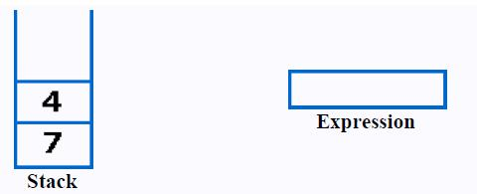

Next character scanned is "-", which is an operator. Thus, we pop the top two elements from the stack and perform the "-" operation with the two operands. The second operand will be the first element that is popped.
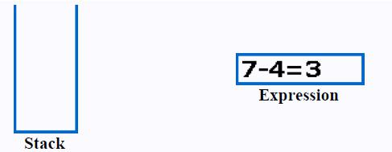

The value of the expression (7-4) that has been evaluated(3) is pushed into the stack.

Data Structures with C Lab
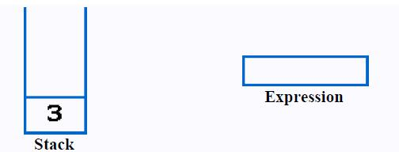

Now, since all the characters are scanned, the remaining element in the stack (there will be only one element in the stack) will be returned.

End result:
Postfix String: 123*+4-
Result: 3

ALGORITHM:
Step 1: Start.
Step 2: Read the postfix/suffix expression.

Step 3: Evaluate the postfix expression based on the precedence of the operator.
Step 4: Stop.

Data Structures with C Lab
ALGORITHM:
Step 1: Start.
Step 2: Read N number of discs.
Step 3: Move all the discs from source to destination by using temp rod.
Step 4: Stop.
PROGRAM CODE:
PROGRAM 5A:
#include<stdio.h>
#include<conio.h>
#include<math.h>
#include<string.h>
double compute(char symbol, double op1, double op2)
{
switch(symbol)
{
case '+': | return op1 + op2;
case' -': | return op1 - op2;
case '*': | return op1 * op2;
case '/': | return op1 / op2;
case '$':
case '^': | return pow(op1,op2);
default: | return 0;
}
}

void main()
{
double s[20], res, op1, op2;
int top, i;
char postfix[20], symbol;
clrscr();
printf("\nEnter the postfix expression:\n");
flushall();
gets(postfix);
top=-1;

for(i=0; <strlen(postfix); i++)
{
symbol = postfix[i];
if(isdigit(symbol))
s[++top] = symbol - '0';
else
{
op2 = s[top--];
op1 = s[top--];

Data Structures with C Lab

res = compute(symbol, op1, op2);
s[++top] = res;
}
}
res = s[top--];
printf("\nThe result is : %f\n", res);
getch();
}

SAMPLE OUTPUT:

RUN1:

Enter the postfix expression:
23+

The result is: 5.000000

RUN2:

Enter the postfix expression:
23+7*

The result is: 35.000000

Data Structures with C Lab

Data Structures with C Lab

EXPERIMENT - 06

Design, Develop and Implement a menu driven Program in C for the following operations on QUEUE of Characters (Array Implementation of Queue with maximum size MAX)

a. Insert an Element on to QUEUE
b. Delete an Element from QUEUE

c. Demonstrate Overflow and Underflow situations on QUEUE d. Display the status of QUEUE e. Exit

Support the program with appropriate functions for each of the above operations

ALGORITHM:
Step 1: Start.
Step 2: Initialize queue size to MAX.
Step 3: Insert the elements into circular queue. If queue is full give a message as ‘queue is overflow”

Step 4: Delete an element from the circular queue. If queue is empty give a message as ‘queue is underflow’.

Step 5: Display the contents of the queue.
Step 6: Stop.

ABOUT THE EXPERIMENT:
Circular queue is a linear data structure. It follows FIFO principle. In circular queue the last node is connected back to the first node to make a circle. Circular linked list fallow the First In First Out principle. Elements are added at the rear end and the elements are deleted at front end of the queue. The queue is considered as a circular queue when the positions 0 and MAX-1 are adjacent. Any position before front is also after rear.

Data Structures with C Lab

PROGRAM CODE:

#include<stdio.h>
#include<conio.h>
#define MAX 4

int ch, front = 0, rear = -1, count=0;
char q[MAX], item;

void insert()
{
if(count == MAX)
printf("\nQueue is Full");
else {
rear = (rear + 1) % MAX;
q[rear]=item;

count++;
}
}

void del()
{
if(count == 0)
printf("\nQueue is Empty");
else

Data Structures with C Lab

{
if(front > rear && rear==MAX-1)
{
front=0; rear=-1; count=0;
}

else
{
item=q[front];
printf("\nDeleted item is: %c",item);
front = (front + 1) % MAX;
count--;
}

}
}

void display()
{
int i, f=front, r=rear;
if(count == 0)
printf("\nQueue is Empty");
else
{
printf("\nContents of Queue is:\n");
for(i=f; i<=r; i++)

{
printf("%c\t", q[i]);
f = (f + 1) % MAX;
}
}
}

void main()
{
clrscr();
do
{
printf("\n1. Insert\n2. Delete\n3. Display\n4. Exit");

printf("\nEnter the choice: ");
scanf("%d", &ch);
flushall();
switch(ch)
{

case 1: printf("\nEnter the character / item to be inserted: "); scanf("%c", &item);

insert();
break;

Data Structures with C Lab

case 2: del();
break;
case 3: display();
break;
case 4: exit(0);
break;
}
}while(ch!=4);
getch();
}

SAMPLE POUTPUT:
1. Insert | 2. | Delete | 3. Display | 4. Exit
Enter the choice: |  | 1
Enter the character / item to be inserted: |  |  |  | A
1. Insert | 2. | Delete | 3. Display | 4. Exit
Enter the choice: |  | 1
Enter the character / item to be inserted: |  |  |  | B
1. Insert | 2. | Delete | 3. Display | 4. Exit
Enter the choice: |  | 1
Enter the character / item to be inserted: |  |  |  | C
1. Insert | 2. | Delete | 3. Display | 4. Exit
Enter the choice: |  | 1
Enter the character / item to be inserted: |  |  |  | D
1. Insert | 2. | Delete | 3. Display | 4. Exit
Enter the choice: |  | 3

Contents of Queue is:
A B C D

1. Insert | 2. Delete |  | 3. Display | 4. Exit
Enter the choice: |  | 1
Enter the character / item to be inserted: |  |  |  | F
Queue is Full
1. Insert | 2. Delete |  | 3. Display | 4. Exit
Enter the choice: |  | 2
Deleted item is: |  | A

Data Structures with C Lab
1. Insert | 2. Delete |  | 3. Display | 4. Exit
Enter the choice: |  | 2
Deleted item is: |  | B
1. Insert | 2. | Delete | 3. Display | 4. Exit
Enter the choice: |  | 3

Contents of Queue is:
C D

1. Insert |  | 2. | Delete | 3. Display | 4. Exit
Enter the choice: |  |  | 1
Enter the character / item to be inserted: |  |  |  |  | K
1. Insert |  | 2. | Delete | 3. Display | 4. Exit
Enter the choice: |  |  | 3
Contents of Queue is:
C | D | K
1. Insert |  | 2. | Delete | 3. Display | 4. Exit
Enter the choice: |  |  | 4

Data Structures with C Lab

EXPERIMENT - 07

Design, Develop and Implement a menu driven Program in C for the following operations on Singly Linked List (SLL) of Student Data with the fields

a. Create a SLL of N Students Data by using front insertion.
b. Display the status of SLL and count the number of nodes in it c. Perform Insertion and Deletion at End of SLL d. Perform Insertion and Deletion at Front of SLL

e. Demonstrate how this SLL can be used as STACK and QUEUE

f. Exit

ABOUT THE EXPERIMENT:

Linked List is a linear data structure and it is very common data structure which consists of group of nodes in a sequence which is divided in two parts. Each node consists of its own data and the address of the next node and forms a chain. Linked Lists are used to create trees and graphs.
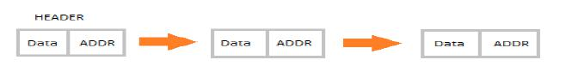

- They are a dynamic in nature which allocates the memory when required.
- Insertion and deletion operations can be easily implemented.
- Stacks and queues can be easily executed.
- Linked List reduces the access time.
- Linked lists are used to implement stacks, queues, graphs, etc.
- Linked lists let you insert elements at the beginning and end of the list.
- In Linked Lists we don’t need to know the size in advance.

Types of Linked List:
Singly Linked List: Singly linked lists contain nodes which have a data part as well as an address part i.e. next, which points to the next node in sequence of nodes. The operations we can perform on singly linked lists are insertion, deletion and traversal.
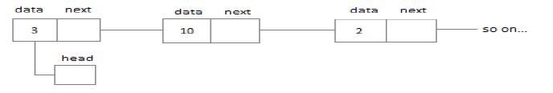

Doubly Linked List: In a doubly linked list, each node contains two links the first link points to the previous node and the next link points to the next node in the sequence.
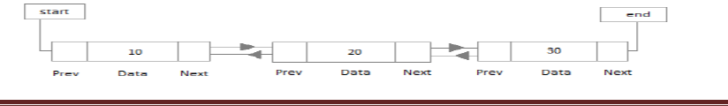

Data Structures with C Lab

- Circular Linked List: In the circular linked list the last node of the list contains the address of the first node and forms a circular chain.
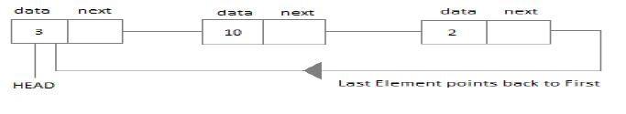

ALGORITHM:
Step 1: Start.
Step 2: Read the value of N. (N student’s information)

Step 2: Create a singly linked list. (SLL)

Step 3: Display the status of SLL.
Step 4: Count the number of nodes.
Step 5: Perform insertion at front of list.
Step 6: Perform deletion at the front of the list.
Step 7: Perform insertion at end of the list.
Step 8: Perform deletion at the end of the list.
Step 9: Demonstrate how singly linked list can be used as stack.
Step 10: Demonstrate how singly linked list can be used as queue.

Step 11: Stop.

PROGRAM CODE:
#include<stdio.h>
#include<conio.h>
int MAX=4, count;
struct student
{
char usn[10];
char name[30];
char branch[5];
int sem;
char phno[10];
struct student *next; | //Self referential pointer.
};
typedef struct student NODE;
int countnodes(NODE *head)
{
NODE *p;
count=0;

Data Structures with C Lab
p=head;
while(p!=NULL)
{
p=p->next;
count++;
}
return count;
}
NODE* getnode(NODE *head)
{
NODE *newnode;
newnode=(NODE*)malloc(sizeof(NODE)); |  | //Create first NODE
printf("\nEnter USN, Name, Branch, Sem, Ph.No\n");
flushall();
gets(newnode->usn);
flushall();
gets(newnode->name);
flushall();
gets(newnode->branch);
scanf("%d",&(newnode->sem));
flushall();
gets(newnode->phno);
newnode->next=NULL; | //Set next to NULL...
head=newnode;
return head;
}

NODE* display(NODE *head)
{
NODE *p;
if(head == NULL)
printf("\nNo student data\n");
else
{
p=head;

printf("\n----STUDENT DATA----\n");
printf("\nUSN\tNAME\t\tBRANCH\tSEM\tPh.NO.");
while(p!=NULL)
{
printf("\n%s\t%s\t\t%s\t%d\t%s", p->usn, p->name, p->branch, p->sem, p->phno);
p = p->next; //Go to next node...
}
printf("\nThe no. of nodes in list is: %d",countnodes(head));
}

Data Structures with C Lab

return head;
}

NODE* create(NODE *head)
{
NODE *newnode;
if(head==NULL)

{
newnode=getnode(head);

head=newnode;
}
else

{
newnode=getnode(head);
newnode->next=head;
head=newnode;
}
return head;
}

NODE* insert_front(NODE *head)
{
if(countnodes(head)==MAX)
printf("\nList is Full / Overflow!!");
else
head=create(head); //create()insert nodes at front.
return head;
}

NODE* insert_rear(NODE *head)
{
NODE *p, *newnode;
p=head;
if(countnodes(head) == MAX)

printf("\nList is Full(QUEUE)!!");
else
{
if(head == NULL)
{
newnode=getnode(head);
head=newnode; //set first node to be head
}
else
{
Data Structures with C Lab

newnode=getnode(head);
while(p->next!=NULL)
{
p=p->next;
}
p->next=newnode;
}
}
return head;
}

NODE* insert(NODE *head)
{

int ch;
do
{
printf("\n1.Insert at Front(First)\t2.Insert at End(Rear/Last)\t3.Exit");
printf("\nEnter your choice: ");
scanf("%d", &ch);
switch(ch)
{
case 1: head=insert_front(head); break;
case 2: head=insert_rear(head); break;
case 3: break;
}
head=display(head);
}while(ch!=3);
return head;
}

NODE* delete_front(NODE *head)
{
NODE *p;
if(head==NULL)
printf("\nList is Empty/Underflow (STACK/QUEUE)");
else

{
p=head;
head=head->next; //Set 2nd NODE as head
free(p);
printf("\nFront(first)node is deleted");
}
return head;
}
Data Structures with C Lab

NODE* delete_rear(NODE *head)
{
NODE *p, *q;
p=head;
while(p->next!=NULL)
{
p=p->next; //Go upto -1 NODE which you want to delete
}
q=p->next;
free(q);//Delete last NODE...
p->next=NULL;

printf("\nLast(end) entry is deleted");
return head;

}

NODE* del(NODE *head)
{
int ch;
do{
printf("\n1.Delete from Front(First)\t2. Delete from End(Rear/Last))\t3.Exit");
printf("\nEnter your choice: ");
scanf("%d",&ch);
switch(ch)
{
case 1: head=delete_front(head);
break;
case 2: head=delete_rear(head);
break;
case 3: break;
}
head=display(head);
}while(ch!=3);
return head;
}

NODE* stack(NODE *head)

{
int ch;
do
{
printf("\nSSL used as Stack...");
printf("\n 1.Insert at Front(PUSH) \t 2.Delete from Front(POP))\t3.Exit");
printf("\nEnter your choice: ");
scanf("%d", &ch);
switch(ch)
{

Data Structures with C Lab

case 1: head=insert_front(head); break;
case 2: head=delete_front(head); break;
case 3: break;
}
head=display(head);
}while(ch!=3);
return head;
}

NODE* queue(NODE *head)
{
int ch;
do

{
printf("\nSSL used as Queue...");
printf("\n 1.Insert at Rear(INSERT) \t 2.Delete from Front(DELETE))\t3.Exit");
printf("\nEnter your choice: ");

scanf("%d", &ch);
switch(ch)
{
case 1: head=insert_rear(head); break;
case 2: head=delete_front(head); break;
case 3: break;
}
head=display(head);
}while(ch!=3);
return head;
}

void main()
{
int ch, i, n;

head=NULL;
clrscr();

printf("\n*----------Studednt Database-----------*");
do
{
printf("\n 1.Create\t 2.Display\t 3.Insert\t 4.Delete\t 5.Stack\t 6.Queue\t 7.Exit");
printf("\nEnter your choice: ");
scanf("%d", &ch);
switch(ch)
{

case 1: printf("\nHow many student data you want to create: "); scanf("%d", &n);
Data Structures with C Lab

for(i=0;i<n;i++)
head=create(head);//Call to Create NODE...
break;

case 2: head=display(head);

//Call to Display...

break;

case 3: head=insert(head);

//Call to Insert...

break;

case 4: head=del(head);
//Call to delete

break;
case 5: head=stack(head);
break;

case 6: head=queue(head);

break;

case 7: exit();

//Exit...

}
}while(ch!=7);
}

SAMPLE OUTPUT:

- Create 2. Display 3. Insert 4. Delete 5. Stack 6.Queue 7. Exit Enter your choice: 1

How many student data you want to create: 2 Enter USN, Name, Branch, Sem, Ph.No

1kt12cs001 | kumar |  | cs | 3 | 9900099000
Enter USN, Name, Branch, Sem, Ph.No
1kt12is002 | ravi | is | 3 | 9900099111

- Create 2. Display 3. Insert 4. Delete 5. Stack 6.Queue 7. Exit Enter your choice: 2

----STUDENT DATA----

USN | NAME | BRANCH | SEM | Ph.NO.
1kt12is002 | ravi | is | 3 | 9900099111
1kt12cs001 | kumar | cs | 3 | 9900099000

- Create 2. Display 3. Insert 4. Delete 5. Stack 6.Queue 7. Exit Enter your choice: 3

- Insert at Front(First) 2.Insert at End(Rear/Last) 3.Exit

Data Structures with C Lab
Enter your choice: 1
Enter USN, Name, Branch, Sem, Ph.No
1kt12cs003 | suresh | cs | 3 | 99000992222
----STUDENT DATA----
USN | NAME | BRANCH | SEM | Ph.NO.
1kt12cs003 | suresh | cs | 3 | 99000992222
1kt12is002 | ravi | is | 3 | 9900099111
1kt12cs001 | kumar | cs | 3 | 9900099000

1.Insert at Front(First) 2.Insert at End(Rear/Last) 3.Exit

Enter your choice: 2
Enter USN, Name, Branch, Sem, Ph.No
1kt12is004 | naresh | is | 3 | 99000993333
----STUDENT DATA----
USN | NAME | BRANCH | SEM | Ph.NO.
1kt12cs003 | suresh | cs | 3 | 99000992222
1kt12is002 | ravi | is | 3 | 9900099111
1kt12cs001 | kumar | cs | 3 | 9900099000
1kt12is004 | naresh | is | 3 | 99000993333

1.Insert at Front(First) 2.Insert at End(Rear/Last) 3.Exit Enter your choice: 3

- Create 2. Display 3. Insert 4. Delete 5. Stack 6.Queue 7. Exit Enter your choice: 4

- Delete from Front (First) 2. Delete from End (Rear/Last) 3.Exit Enter your choice: 1

Front (first) node is deleted

----STUDENT DATA----
USN | NAME | BRANCH | SEM | Ph.NO.
1kt12is002 | ravi | is | 3 | 9900099111
1kt12cs001 | kumar | cs | 3 | 9900099000
1kt12is004 | naresh | is | 3 | 99000993333

Data Structures with C Lab

The no. of nodes in list is: 3

- Delete from Front (First) 2. Delete from End (Rear/Last) 3.Exit Enter your choice: 2

Last (end) node is deleted

----STUDENT DATA----
USN | NAME | BRANCH | SEM | Ph.NO.
1kt12is002 | ravi | is | 3 | 9900099111
1kt12cs001 | kumar | cs | 3 | 9900099000

- Delete from Front (First) 2. Delete from End (Rear/Last) 3.Exit Enter your choice: 3

- Create 2. Display 3. Insert 4. Delete 5. Stack 6.Queue 7. Exit Enter your choice: 5

SSL used as Stack...

- Insert at Front(PUSH) 2.Delete from Front(POP)) 3.Exit Enter your choice: 1

Enter USN, Name, Branch, Sem, Ph.No 1kt12is010 vikky is 3 9900011111
----STUDENT DATA----

USN | NAME | BRANCH | SEM | Ph.NO.
1kt12is010 | vikky | is | 3 | 9900011111
1kt12is002 | ravi | is | 3 | 9900099111
1kt12cs001 | kumar | cs | 3 | 9900099000

- Create 2. Display 3. Insert 4. Delete 5. Stack 6.Queue 7. Exit Enter your choice: 7

Data Structures with C Lab

EXPERIMENT - 08

Design, Develop and Implement Program in C to Reverse a Singly Linked List (SLL) of a given integers.

Explaination:
Step 1: Create two more pointers other than head namely prevNode and curNode that will hold the reference of previous node and current node respectively.
Make sure that prevNode points to first node i.e. prevNode = head.
head should now point to its next node i.e. the second node head = head->next.
curNode should also points to the second node i.e. curNode = head.
Reverse of singly linked list2
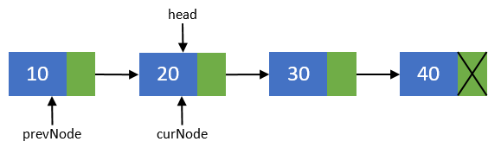
Step 2: Now, disconnect the previous node i.e. the first node from others. We will make sure that it points to none. As this node is going to be our last node. Perform operation prevNode->next = NULL.
Reverse of singly linked list3
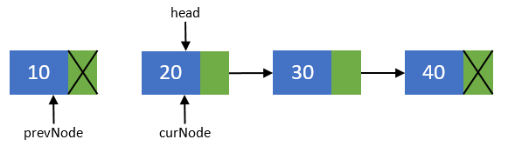

Step 3: Move head node to its next node i.e. head = head->next.
Reverse of singly linked list4
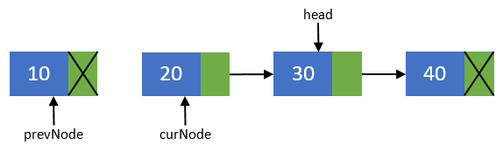
Step 4: Now, re-connect the current node to its previous node i.e. curNode->next = prevNode;.
Reverse of singly linked list5
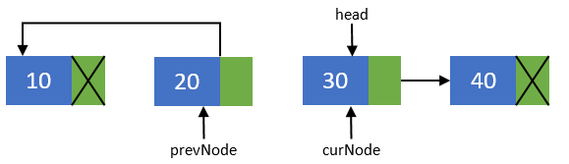

Step 5: Point the previous node to current node and current node to head node. Means they should now point to prevNode = curNode; and curNode = head.
Reverse of singly linked list6
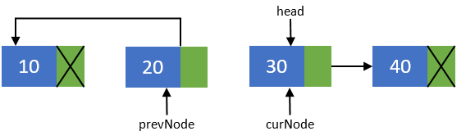
Step 6: Repeat steps 3-5 till head pointer becomes NULL.
Reverse of singly linked list61
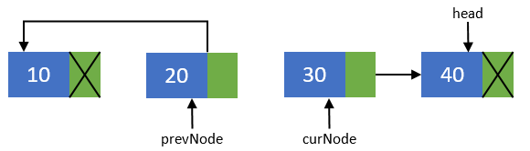
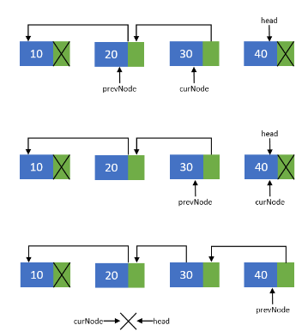

Now, after all nodes has been re-connected in the reverse order. Make the last node as the first node. Means the head pointer should point to prevNode pointer. Perform head = prevNode;. Finally you end up with a reversed linked list of its original.
Reverse of singly linked list10
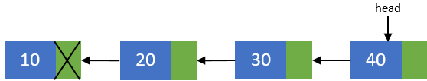

Program Code:

#include<stdio.h> #include<malloc.h> struct node
{
int value;
struct node *next;
};
int main()
{
int item,n;
struct node * head; struct node * tail; struct node * temp; struct node * prev; struct node * current; struct node * next;
temp=(struct node*)malloc(sizeof(struct node)); head=temp;
printf("enter the size of list\n"); scanf("%d",&n);
printf("enter the list to be reversed\n");
temp = (struct node *)malloc(sizeof(struct node)); scanf("%d",&item);
temp->value = item; head = temp;
n--;
while(n!=0)
{
temp->next = (struct node *)malloc(sizeof(struct node)); temp = temp->next;
scanf("%d",&item); temp->value = item;
--n;
}
temp->next = NULL; tail = temp;
temp = head;
while(temp)
{
printf(" %d\n", temp->value); temp = temp->next;
}
printf("Reversing the linked list\n"); prev = NULL;
current = next = head; while(current)
{
next = current->next; current->next = prev; prev = current; current = next;
}
temp = tail; while(temp)
{
printf(" %d\n", temp->value); temp = temp->next;
}
return 0;
}
Output:
Enter the total number of nodes: 5
Enter the data of node 1: 10
Enter the data of node 2: 20
Enter the data of node 3: 30
Enter the data of node 4: 40
Enter the data of node 5: 50
SINGLY LINKED LIST CREATED SUCCESSFULLY

Data in the list
Data = 10
Data = 20
Data = 30
Data = 40
Data = 50

Data Structures with C Lab

EXPERIMENT - 09

Design, Develop and Implement a menu driven Program in C for the following operations on Priority queue
- Create a Priority queue by using Insert function
- Insertion data and priority values as input
- Perform Deletion operation
- Display the elements of Priority queue

Program Code:

# include<stdio.h>
# include<malloc.h>

typedef struct node
{
int priority; int info;
struct node *link;
}NODE;
NODE *front = NULL;

void insert(int item,int priority)
{
NODE *tmp,*q;
tmp = (NODE *)malloc(sizeof(NODE)); tmp->info = item;
tmp->priority = priority;
if( front == NULL || priority < front->priority )
{

}
else
{

}
}
tmp->link = front; front = tmp;

q = front;
while( q->link != NULL && q->link->priority <= priority ) q=q->link;
tmp->link = q->link; q->link = tmp;

void del()
{
NODE *tmp; if(front == NULL)
printf("Queue Underflow\n");

else
{

}
}

tmp = front;
printf("Deleted item is %d\n",tmp->info); front = front->link;
free(tmp);

void display()
{
NODE *ptr; ptr = front;
if(front == NULL)
printf("Queue is empty\n");
else
{
printf("Queue is :\n"); printf("Priority Item\n"); while(ptr != NULL)
{
printf("%5d %5d\n",ptr->priority,ptr->info); ptr = ptr->link;
}
}
}

int main()
{
int choice,item,priority; do
{
printf("1.Insert\n"); printf("2.Delete\n"); printf("3.Display\n"); printf("4.Quit\n"); printf("Enter your choice : "); scanf("%d", &choice); switch(choice)

{
case 1:
printf("Input the item value to be added in the queue : "); scanf("%d",&item);
printf("Enter its priority : "); scanf("%d",&priority); insert(item,priority);
break; case 2:
del(); break;
case 3:
display(); break;
case 4:
exit(0); break; default :
printf("Wrong choice\n");
}
}while(choice!=4); return 0;
}

Data Structures with C Lab

EXPERIMENT - 10

Design, Develop and Implement a menu driven Program in C for the following operations on Binary Search Tree (BST) of Integers

a. Create a BST of N Integers: 6, 9, 5, 2, 8, 15, 24, 14, 7, 8, 5, 2 b. Traverse the BST in Inorder, Preorder and Post Order

c. Search the BST for a given element (KEY) and report the appropriate message d. Delete an element (ELEM) from BST e. Exit

ABOUT THE EXPERIMENT:
A binary search tree (BST) is a tree in which all nodes follows the below mentioned properties

- The left sub-tree of a node has key less than or equal to its parent node's key.
- The right sub-tree of a node has key greater than or equal to its parent node's key.

Thus, a binary search tree (BST) divides all its sub-trees into two segments; left sub-tree and right sub-tree and can be defined as

left_subtree (keys) ≤ node (key) ≤ right_subtree (keys)
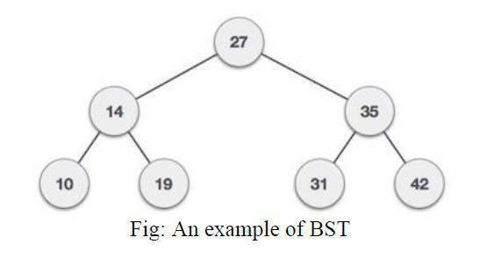

Following are basic primary operations of a tree which are following.
- Search − search an element in a tree.
- Insert − insert an element in a tree.

- Preorder Traversal − traverse a tree in a preorder manner.

- Inorder Traversal − traverse a tree in an inorder manner.
- Postorder Traversal − traverse a tree in a postorder manner.

Data Structures with C Lab

Node definition: Define a node having some data, references to its left and right child nodes. struct node
{
int data;
struct node *leftChild;

struct node *rightChild;
};

ALGORITHM:
Step 1: Start.
Step 2: Create a Binary Search Tree for N elements.

Step 3: Traverse the tree in inorder.
Step 4: Traverse the tree in preorder

Step 6: Traverse the tree in postorder.
Step 7: Search the given key element in the BST.
Step 8: Delete an element from BST.
Step 9: Stop

PROGRAM CODE:

#include <stdio.h>
#include <stdlib.h>

struct BST
{
int data;
struct BST *left;
struct BST *right;
};

typedef struct BST NODE;

NODE *node;

NODE* createtree(NODE *node, int data)
{
if (node == NULL)

{
NODE *temp;
temp= (NODE*)malloc(sizeof(NODE));
temp->data = data;
temp->left = temp->right = NULL;
return temp;
}
if (data < (node->data))
{

Data Structures with C Lab

node->left = createtree(node->left, data);
}
else if (data > node->data)
{
node -> right = createtree(node->right, data);
}
return node;
}

NODE* search(NODE *node, int data)
{
if(node == NULL)
printf("\nElement not found");

else if(data < node->data)
{
node->left=search(node->left, data);
}
else if(data > node->data)
{
node->right=search(node->right, data);
}
else

printf("\nElement found is: %d", node->data); return node;

}

void inorder(NODE *node)
{
if(node != NULL)
{
inorder(node->left);
printf("%d\t", node->data);
inorder(node->right);
}
}

void preorder(NODE *node)
{
if(node != NULL)
{
printf("%d\t", node->data);
preorder(node->left);
preorder(node->right);
}
}

Data Structures with C Lab

void postorder(NODE *node)
{
if(node != NULL)
{
postorder(node->left);
postorder(node->right);
printf("%d\t", node->data);

}
}

NODE* findMin(NODE *node)

{
if(node==NULL)
{
return NULL;
}
if(node->left)
return findMin(node->left);
else
return node;
}

NODE* del(NODE *node, int data)
{
NODE *temp;
if(node == NULL)
{
printf("\nElement not found");
}
else if(data < node->data)
{
node->left = del(node->left, data);
}
else if(data > node->data)

{
node->right = del(node->right, data);
}
else
{ /* Now We can delete this node and replace with either minimum element in the right sub tree or maximum element in the left subtree */
if(node->right && node->left)
{ /* Here we will replace with minimum element in the right sub tree */

temp = findMin(node->right);
node -> data = temp->data;

/* As we replaced it with some other node, we have to delete that node */
node -> right = del(node->right,temp->data);

Data Structures with C Lab

}
else
{

/* If there is only one or zero children then we can directly remove it from the tree and connect its parent to its child */

temp = node;
if(node->left == NULL)

node = node->right;
else if(node->right == NULL)
node = node->left;
free(temp); /* temp is longer required */
}
}

return node;
}

void main()
{
int data, ch, i, n;
NODE *root=NULL;
clrscr();
while (1)
{

printf("\n1.Insertion in Binary Search Tree"); printf("\n2.Search Element in Binary Search Tree"); printf("\n3.Delete Element in Binary Search Tree"); printf("\n4.Inorder\n5.Preorder\n6.Postorder\n7.Exit"); printf("\nEnter your choice: "); scanf("%d", &ch);

switch (ch)
{
case 1: printf("\nEnter N value: " );
scanf("%d", &n);
printf("\nEnter the values to create BST like(6,9,5,2,8,15,24,14,7,8,5,2)\n");
for(i=0; i<n; i++)
{
scanf("%d", &data);
root=createtree(root, data);
}

break;
case 2: printf("\nEnter the element to search: ");
scanf("%d", &data);
root=search(root, data);
break;
case 3: printf("\nEnter the element to delete: ");
scanf("%d", &data);
root=del(root, data);
break;

Data Structures with C Lab

case 4: printf("\nInorder Traversal: \n");
inorder(root);
break;
case 5: printf("\nPreorder Traversal: \n");
preorder(root);
break;
case 6: printf("\nPostorder Traversal: \n");
postorder(root);
break;
case 7: exit(0);
default:printf("\nWrong option");
break;
}
}

getch();
}

SAMPLE OUTPUT:
- Insertion in Binary Search Tree

- Search Element in Binary Search Tree 3. Delete Element in Binary Search Tree 4. Inorder

Preorder

Postorder
- Exit
Enter your choice:1
Enter N value: 12
Enter the values to create BST like(6,9,5,2,8,15,24,14,7,8,5,2)

6 9 5 2 8 15 24 14 7 8 5 2

- Insertion in Binary Search Tree

- Search Element in Binary Search Tree 3. Delete Element in Binary Search Tree 4. Inorder

Preorder

Postorder
- Exit
Enter your choice:4

Inorder Traversal:
2 | 5 | 6 | 7 | 8 | 9 | 14 | 15 | 24
1. Insertion in Binary Search Tree

Data Structures with C Lab

- Search Element in Binary Search Tree 3. Delete Element in Binary Search Tree 4. Inorder

Preorder

Postorder
- Exit
Enter your choice:5

Preorder Traversal:
6 | 5 | 2 | 9 | 8 | 7 | 15 | 14 | 24

- Insertion in Binary Search Tree

- Search Element in Binary Search Tree 3. Delete Element in Binary Search Tree 4. Inorder

Preorder

Postorder

- Exit
Enter your choice:6

Postorder Traversal:
2 | 5 | 7 | 8 | 14 | 24 | 15 | 9 | 6

- Insertion in Binary Search Tree

- Search Element in Binary Search Tree 3. Delete Element in Binary Search Tree 4. Inorder

Preorder

Postorder

- Exit

Enter your choice: 2 Enter the element to search: 24 Element found is: 24

- Insertion in Binary Search Tree

- Search Element in Binary Search Tree 3. Delete Element in Binary Search Tree 4. Inorder

Preorder

Data Structures with C Lab

Postorder
7. Exit
Enter your choice: 2
Enter the element to
search: 50

Element not found

- Insertion in Binary Search Tree

- Search Element in Binary Search Tree 3. Delete Element in Binary Search Tree 4. Inorder

Preorder

Postorder
- Exit

Enter your choice: 3 Enter the element to search: 15

- Insertion in Binary Search Tree

- Search Element in Binary Search Tree 3. Delete Element in Binary Search Tree 4. Inorder

Preorder

Postorder
- Exit
Enter your choice:4

Inorder Traversal:
2 | 5 | 6 | 7 | 8 | 9 | 14 | 24

- Insertion in Binary Search Tree

- Search Element in Binary Search Tree 3. Delete Element in Binary Search Tree 4. Inorder

Preorder

Postorder
- Exit

Enter your choice:5

Preorder Traversal:
6 | 5 | 2 | 9 | 8 | 7 | 24 | 14

Data Structures with C Lab

- Insertion in Binary Search Tree

- Search Element in Binary Search Tree 3. Delete Element in Binary Search Tree 4. Inorder

Preorder

Postorder
- Exit

Enter your choice:7

Data Structures with C Lab

EXPERIMENT - 11

Given a File of N employee records with a set K of Keys(4-digit) which uniquely determine the records in file F. Assume that file F is maintained in memory by a Hash Table(HT) of m memory locations with L as the set of memory addresses (2-digit) of locations in HT. Let the keys in K and addresses in L are Integers. Design and develop a Program in C that uses Hash function H: K ® L as H(K)=K mod m (remainder method), and implement hashing technique to map a given key K to the address space L. Resolve the collision (if any) using linear probing.

ABOUT THE EXPERIMENT:

Hash Table is a data structure which store data in associative manner. In hash table, data is stored in array format where each data values has its own unique index value. Access of data becomes very fast if we know the index of desired data.

Thus, it becomes a data structure in which insertion and search operations are very fast irrespective of size of data. Hash Table uses array as a storage medium and uses hash technique to generate index where an element is to be inserted or to be located from.

Hashing: Hashing is a technique to convert a range of key values into a range of indexes of an array. We're going to use modulo operator to get a range of key values. Consider an example of hashtable of size 20, and following items are to be stored. Item are in (key, value) format.
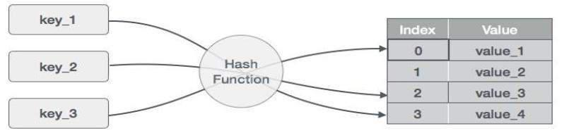

(1,20) (2,70) (42,80) |  | (4,25) (12,44) |  | (14,32) |  | (17,11) | (13,78)
(37,98)
 | S.n. | Key | Hash |  |  | Array Index
 | 1 | 1 | 1 | % 20 | = 1 | 1
 | 2 | 2 | 2 | % 20 | = 2 | 2
 | 3 | 42 | 42%20=2 |  |  | 2

Data Structures with C Lab
 | 4 | 4 |  | 4 | % 20 |  | = 4 | 4
 | 5 | 12 | 12 |  | % 20 |  | = 12 | 12
 | 6 | 14 | 14 |  | % 20 |  | = 14 | 14
 | 7 | 17 | 17 | % 20 |  | = 17 |  | 17
 | 8 | 13 | 13 | % 20 |  | = 13 |  | 13
 | 9 | 37 | 37 | % 20 |  | = 17 |  | 17

Linear Probing

As we can see, it may happen that the hashing technique used create already used index of the array. In such case, we can search the next empty location in the array by looking into the next cell until we found an empty cell. This technique is called linear probing.

S.n. | Key | Hash |  |  | Array Index
1 | 1 | 1 | %20=1 |  | 1
2 | 2 | 2 | % 20 | = 2 | 2
3 | 42 | 42%20=2 |  |  | 2
4 | 4 | 4 | % 20 | = 4 | 4
5 | 12 | 12 | % 20 | = 12 | 12
6 | 14 | 14 | % 20 | = 14 | 14

Data Structures with C Lab
 | 7 | 17 | 17 | % 20 |  | = 17 |  | 17
 | 8 | 13 | 13 | % | 20 | = | 13 | 13
 | 9 | 37 | 37 | % | 20 | = | 17 | 17

Basic Operations

Search − search an

element in a hashtable.

Insert − insert an element in a hashtable.
delete − delete an element from a hashtable.

DataItem

Define a data item having some data, and key based on which search is to be conducted in hashtable.

struct DataItem
{
int data;

int key;

};

HashMethod
Define a hashing method to compute the hash code of the key of the data item.

int hashCode(int key)
{
return key % SIZE;
}

ALGORITHM:
Step 1: Start.

Step 2: Given a File of N employee records with a set K of Keys (4-digit) which uniquely determine the records in file F.

Step 3: Assume that file F is maintained in memory by a Hash Table(HT) of m memory locations with L as the set of memory addresses (2-digit) of locations in HT.

Step 3: Let the keys in K and addresses in L are Integers
Step 4: Hash function H: K ® L as H(K)=K mod m (remainder method)
Step 5: Hashing as to map a given key K to the address space L, Resolve the collision (if any) is using linear probing.

Step6: Stop.

Data Structures with C Lab

PROGRAM CODE:

#include <stdio.h>

#include <stdlib.h>

#define MAX 10

struct employee {

int id;

char name[15]; };

typedef struct employee EMP;

EMP emp[MAX];

int a[MAX];

int create(int num) {

int key;

key = num % 100;

return key;

}

int getemp(EMP emp[],int key)

{

printf("\nEnter emp id: ");

scanf("%d",&emp[key].id);

printf("\nEnter emp name: ");

flushall();

gets(emp[key].name);

return key;

}

void display() {

int i, ch;

printf("\n1.Display ALL\n2.Filtered Display");

printf("\nEnter the choice: ");

scanf("%d",&ch);

if(ch == 1)

{

printf("\nThe hash table is:\n");

printf("\nHTKey\tEmpID\tEmpName");

for(i=0; i<MAX; i++)

printf("\n%d\t%d\t%s", i, emp[i].id, emp[i].name);

}

Data Structures with C Lab

else

{

printf("\nThe hash table is:\n");

printf("\nHTKey\tEmpID\tEmpName");

for(i=0; i<MAX; i++)

if(a[i] != -1)

{

printf("\n%d\t%d\t%s", i, emp[i].id, emp[i].name);

continue;

}

}

}

void linear_prob(int key, int num)

{

int flag, i, count = 0; flag = 0;

if(a[key] == -1)

{

a[key]=getemp(emp, key);

}

else

{

printf("\nCollision Detected...!!!\n");

i = 0;

while(i < MAX)

{

if (a[i] != -1)

count++;

else

i++;

}

printf("\nCollision avoided successfully using LINEAR PROBING\n");

if(count == MAX)

{

printf("\n Hash table is full");

display(emp);

exit(1);

}

for(i=key; i<MAX; i++)

if(a[i] == -1)

{

Data Structures with C Lab

a[i] = num;

flag = 1;

break;

}

i = 0;

while((i < key) && (flag == 0))

{

if(a[i] == -1)

{

a[i] = num;

flag=1; break;

}

i++;

} // end while

} // end else

} // end linear_prob()

void main()

{

int num, key, i;

int ans = 1;

clrscr();

printf("\nCollision handling by linear probing: ");

for (i=0; i < MAX; i++)

{

a[i] = -1;

}

do

{

printf("\nEnter the data: ");

scanf("%d", &num);

key=create(num);

linear_prob(key,num);

printf("\nDo you wish to continue? (1/0): ");

scanf("%d",&ans);

}while(ans);

display(emp);

getch();

}

Data Structures with C Lab

SAMPLE OUTPUT:

RUN1:
Enter the data: 2
Enter emp id: 100

Enter emp name: Anand

Do you wish to continue?
(1/0): 1

Enter the data: 4
Enter emp id: 101
Enter emp name:

Kumar

Do you wish to continue? (1/0): | 0

1.Display ALL
2.Filtered
Display Enter
the choice: 1

The hash table is:

HTKey | EmpID | EmpName
0 | 0
1 | 0 | Anand
2 | 100 | Anand
3 | 0 | Kumar
4 | 101 | Kumar
5 | 0
6 | 0
7 | 0
8 | 0
9 | 0

RUN2:
Enter the data: 2

Enter emp id: 100
Enter emp name: Anand

Do you wish to continue? (1/0):1

Enter the data: 4
Enter emp id: 101

Enter emp name: Kumar

Data Structures with C Lab - 19CSL32
Do you wish to continue? (1/0):0
The hash Table is:
HTKey EmpID |  | EmpName
2 | 100 | Anand
4 | 101 | Kumar

Data Structures with C Lab

VIVA QUESTIONS AND ANSWERS

1) What is data structure?

Data structures refers to the way data is organized and manipulated. It seeks to find ways to make data access more efficient. When dealing with data structure, we not only focus on one piece of data, but rather different set of data and how they can relate to one another in an organized manner.

2) Differentiate file structure from storage structure.

Basically, the key difference is the memory area that is being accessed. When dealing with the structure that resides the main memory of the computer system, this is referred to as storage structure. When dealing with an auxiliary structure, we refer to it as file structures.

3) When is a binary search best applied?

A binary search is an algorithm that is best applied to search a list when the elements are already in order or sorted. The list is search starting in the middle, such that if that middle value is not the target search key, it will check to see if it will continue the search on the lower half of the list or the higher half. The split and search will then continue in the same manner.

4) What is a linked list?

A linked list is a sequence of nodes in which each node is connected to the node following it. This forms a chain-like link of data storage.

5) How do you reference all the elements in a one-dimension array?

To do this, an indexed loop is used, such that the counter runs from 0 to the array size minus one. In this manner, we are able to reference all the elements in sequence by using the loop counter as the array subscript.

6) In what areas do data structures applied?

Data structures is important in almost every aspect where data is involved. In general, algorithms that involve efficient data structure is applied in the following areas: numerical analysis, operating system, A.I., compiler design, database management, graphics, and statistical analysis, to name a few.

7) What is LIFO?

LIFO is short for Last In First Out, and refers to how data is accessed, stored and retrieved. Using this scheme, data that was stored last , should be the one to be extracted first. This also means that in order to gain access to the first data, all the other data that was stored before this first data must first be retrieved and extracted.

Data Structures with C Lab

8 ) What is a queue?

A queue is a data structures that can simulates a list or stream of data. In this structure, new elements are inserted at one end and existing elements are removed from the other end.

9) What are binary trees?

A binary tree is one type of data structure that has two nodes, a left node and a right node. In programming, binary trees are actually an extension of the linked list structures.

10) Which data structures is applied when dealing with a recursive function?

Recursion, which is basically a function that calls itself based on a terminating condition, makes use of the stack. Using LIFO, a call to a recursive function saves the return address so that it knows how to return to the calling function after the call terminates.

11) What is a stack?

A stack is a data structure in which only the top element can be accessed. As data is stored in the stack, each data is pushed downward, leaving the most recently added data on top.

12) Explain Binary Search Tree

A binary search tree stores data in such a way that they can be retrieved very efficiently. The left subtree contains nodes whose keys are less than the node’s key value, while the right subtree contains nodes whose keys are greater than or equal to the node’s key value. Moreover, both subtrees are also binary search trees.

13) What are multidimensional arrays?

Multidimensional arrays make use of multiple indexes to store data. It is useful when storing data that cannot be represented using a single dimensional indexing, such as data representation in a board game, tables with data stored in more than one column.

14) Are linked lists considered linear or non-linear data structures?

It actually depends on where you intend to apply linked lists. If you based it on storage, a linked list is considered non-linear. On the other hand, if you based it on access strategies, then a linked list is considered linear.

15) How does dynamic memory allocation help in managing data?

Aside from being able to store simple structured data types, dynamic memory allocation can combine separately allocated structured blocks to form composite structures that expand and contract as needed.

Data Structures with C Lab

16) What is FIFO?

FIFO is short for First-in, First-out, and is used to represent how data is accessed in a queue. Data has been inserted into the queue list the longest is the one that is removed first.

17) What is an ordered list?

An ordered list is a list in which each node’s position in the list is determined by the value of its key component, so that the key values form an increasing sequence, as the list is traversed.

18) What is merge sort?

Merge sort takes a divide-and-conquer approach to sorting data. In a sequence of data, adjacent ones are merged and sorted to create bigger sorted lists. These sorted lists are then merged again to form an even bigger sorted list, which continuous until you have one single sorted list.

19) Differentiate NULL and VOID.

Null is actually a value, whereas Void is a data type identifier. A variable that is given a Null value simply indicates an empty value. Void is used to identify pointers as having no initial size.

20) What is the primary advantage of a linked list?

A linked list is a very ideal data structure because it can be modified easily. This means that modifying a linked list works regardless of how many elements are in the list.

21) What is the difference between a PUSH and a POP?

Pushing and popping applies to the way data is stored and retrieved in a stack. A push denotes data being added to it, meaning data is being “pushed” into the stack. On the other hand, a pop denotes data retrieval, and in particular refers to the topmost data being accessed.

22) What is a linear search?

A linear search refers to the way a target key is being searched in a sequential data structure. Using this method, each element in the list is checked and compared against the target key, and is repeated until found or if the end of the list has been reached.

23) How does variable declaration affect memory allocation?

The amount of memory to be allocated or reserved would depend on the data type of the variable being declared. For example, if a variable is declared to be of integer type, then 32 bits of memory storage will be reserved for that variable.

24) What is the advantage of the heap over a stack?

Basically, the heap is more flexible than the stack. That’s because memory space for the heap can be dynamically allocated and de-allocated as needed. However, memory of the heap can at times be slower when compared to that stack.

Data Structures with C Lab

25) What is a postfix expression?

A postfix expression is an expression in which each operator follows its operands. The advantage of this form is that there is no need to group sub-expressions in parentheses or to consider operator precedence.

26) What is the difference between the HEAP and the STACK?

(Solution: HEAP is used to store dynamically allocated memory (malloc). STACK stores static data (int, const).)

- Where in memory are HEAP and the STACK located relative to the executing program? (Solution: The STACK and HEAP are stored "below" the executing program. The HEAP "grows" toward the program executable while the STACK grows away from it.)

- Describe the data structures of a double-linked list.

(Solution: A double-linked list structure contains one pointer to the previous record in the list and a pointer to the next record in the list plus the record data.)

29) How do you insert a record between two nodes in double-linked list?

(Solution: Previous R; Data R; Next R; To insert a record (B) between two others (A and C):

Previous.B = A; Next.B = C; Next.A = B; Previous.C = B;)

30) In which data structure, elements can be added or removed at either end, but not in the middle?
(Solution: queue)

- Which one is faster? A binary search of an orderd set of elements in an array or a sequential search of the elements.
(Solution: binary search)

- What is a balanced tree?

(Solution: A binary tree is balanced if the depth of two subtrees of every node never differ by more than one)

  - Which data structure is needed to convert infix notations to post fix notations? (Solution: stack)

- What is data structure or how would you define data structure?

(Solution: In programming the term data structure refers to a scheme for organizing related piece of information. Data Structure = Organized Data + Allowed Operations.)

Data Structures with C Lab - 15CSL38

- Which data structures we can implement using link list? (Solution: queue and stack)

- List different types of data structures?

(Solution: Link list, queue, stack, trees, files, graphs)

37) Define a linear and non linear data structure.

Linear data structure: A linear data structure traverses the data elements sequentially, in which only

one data element can directly be reached. Ex: Arrays, Linked Lists

Non-Linear data structure: Every data item is attached to several other data items in a way that is specific for reflecting relationships. The data items are not arranged in a sequential structure. Ex: Trees, Graphs

PROGRAM OUTCOMES
01. Engineering knowledge: Apply the knowledge of mathematics, science, engineering fundamentals, and an engineering specialization to the solution of complex engineering problems.
02. Problem analysis: Identify, formulate, review research literature, and analyse complex engineering problems reaching substantiated conclusions using first principles of mathematics, natural sciences, and engineering sciences.
03. Design/development of solutions: Design solutions for complex engineering problems and design system components or processes that meet the specified needs with appropriate consideration for the public health and safety, and the cultural, societal, and environmental considerations.
04. Conduct investigations of complex problems: Use research-based knowledge and research methods including design of experiments, analysis and interpretation of data, and synthesis of the information to provide valid conclusions.
05. Modern tool usage: Create, select, and apply appropriate techniques, resources, and modern engineering and IT tools including prediction and modelling to complex engineering activities with an understanding of the limitations.
06. The engineer and society: Apply reasoning informed by the contextual knowledge to assess societal, health, safety, legal and cultural issues and the consequent responsibilities relevant to the professional engineering practice.
07. Environment and sustainability: Understand the impact of the professional engineering solutions in societal and environmental contexts, and demonstrate the knowledge of, and need for sustainable development.
08. Ethics: Apply ethical principles and commit to professional ethics and responsibilities and norms of the engineering practice.
09. Individual and team work: Function effectively as an individual, and as a member or leader in diverse teams, and in multidisciplinary settings.
10. Communication: Communicate effectively on complex engineering activities with the engineering community and with society at large, such as, being able to comprehend and write effective reports and design documentation, make effective presentations, and give and receive clear instructions.
11. Project management and finance: Demonstrate knowledge and understanding of the engineering and management principles and apply these to one‘s own work, as a member and leader in a team, to manage projects and in multidisciplinary environments.
12. Life-long learning: Recognize the need for, and have the preparation and ability to engage in independent and life-long learning in the broadest context of technological change.

PROGRAM SPECIFIC OUTCOMES (PSOs)

PSO1: | Acquire competency in hardware and software working principles to analyze and solve computing problems.
PSO2: | Design quality software to develop scientific and business applications following Software Engineering practices.
PSO3: | Apply cutting edge technologies using modern tools to find novel solutions ethically to existing problems.

